**Keycloak with Node Js and EJS**

**Prerequisites:**

1. Docker
2. Node Js ^14
3. NPM ^6

**Reference link to install Prerequisites:**

1. Docker: <https://docs.docker.com/engine/install/>
2. Node Js and NPM: <https://nodejs.org/en/download/>

**Setting up docker with Keycloak image:**

1. Open terminal and past the following command to create a container with user name “admin” and password “password” with database as “H2”.

docker run -e DB_VENDOR=H2 -e KEYCLOAK_USER=admin -e KEYCLOAK_PASSWORD=password -p 8080:8080 --name keycloak -dit jboss/keycloak

1. Once the setup is completed you can access the Keycloak server from browser with this URL: <http://localhost:8080/auth/>

**Setting up Keycloak Server:**

1. Click on the Administrative console:

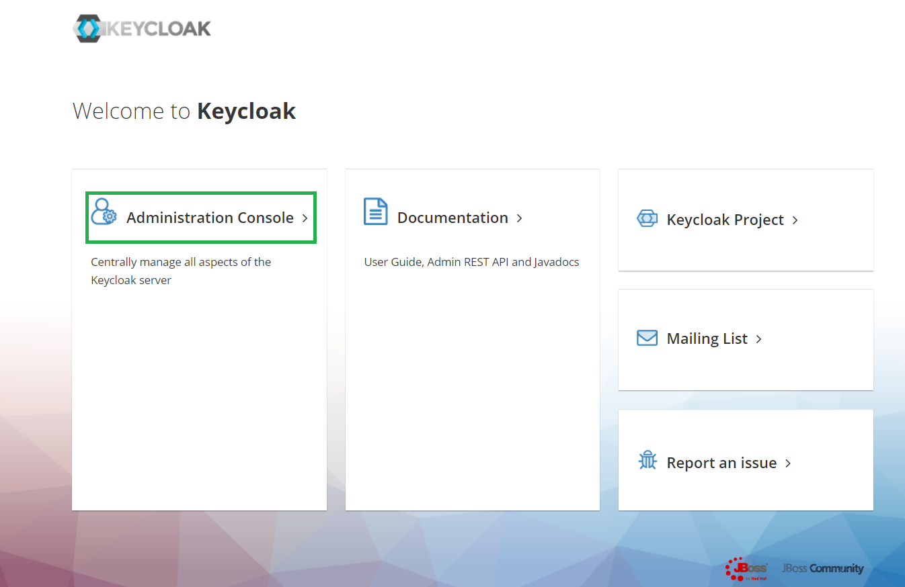

1. Put the same username and password which we used to create a Keycloak container in docker which is user name “admin” and password “password”.

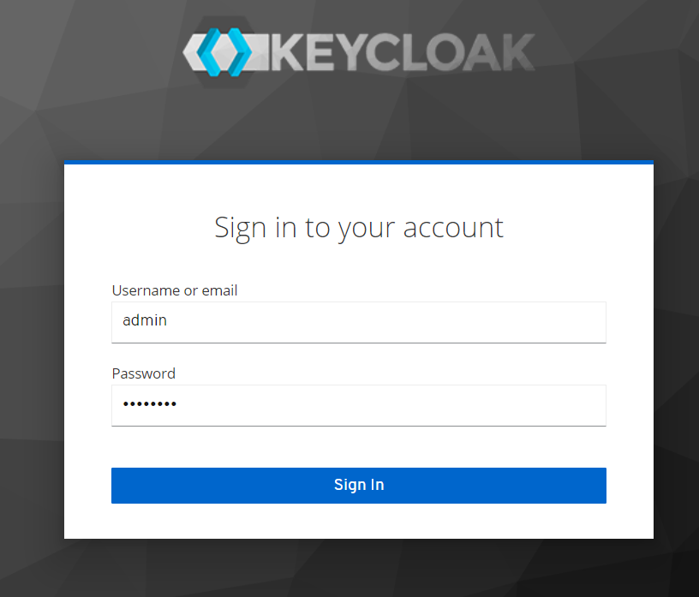

1. Now we have to create a realm for our project. Click on drop down call master and click on add realm.

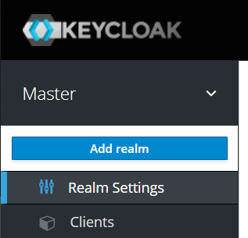

1. Now give the name for the realm like “Nodejs” and click on create.

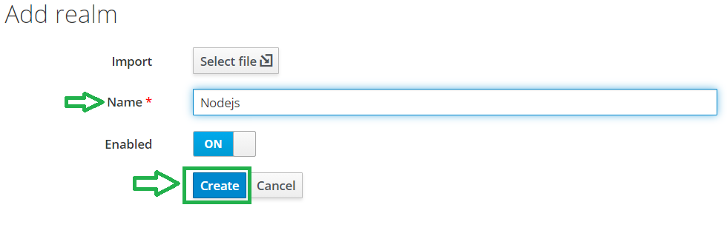

1. Now click on clients in the left menu bar from the Nodejs realm like below

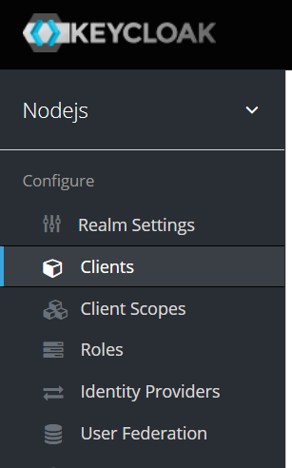

1. Click on Create button.

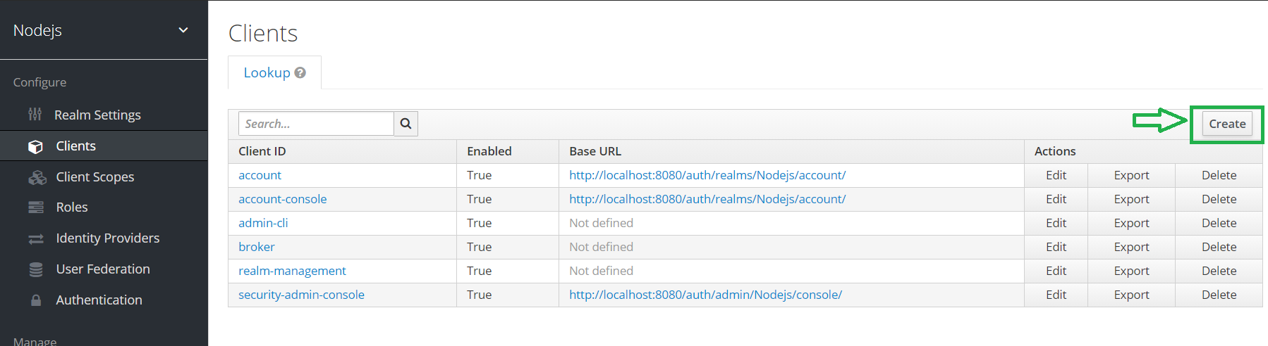

1. Now add the client ID as “backend” , client Protocol to “open-connect” and root URL of Node Js server which is “ <http://localhost:3000/> ” and click on save.

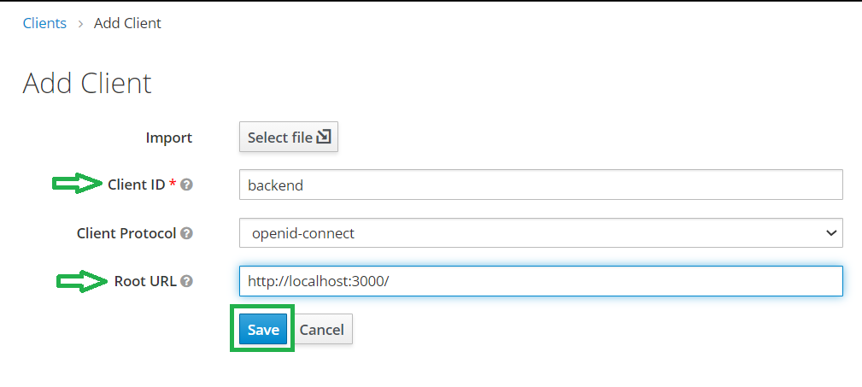

1. Now change the access type to confidential and click on save.

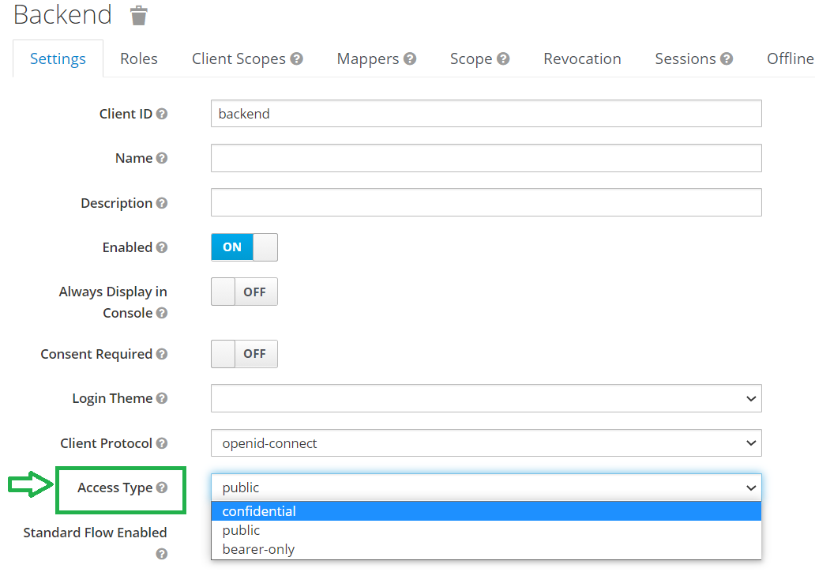

1. Now we have to create users for the realm. Click on users in the menu:

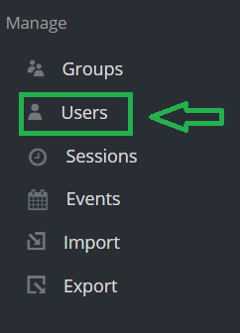

1. Click on add users:

